
School of Computer Science and Engineering

Python For Data Science lab
Mini Project Report
Course Code: B25CS0102  Academic Year: 2025-26 |  | Semester: 1st  Batch: CSE F1/F2
Project Details
Project Title:
Place of Project: | REVA UNIVERSITY, BENGALURU
Student Details:
Name | SRN |  | Sign:
TEJASWINI.S | R25EF291
Guide and Lab Faculty Member Details
Name of the Faculty |  |  | Sign: Date:
Marks by Lab Faculty(10M)

CONTENT
1 | Abstract | Page No.
2 | Introduction | Page No.
3 | Objective of the project | Page No.
4 | Software Components | Page No.
5 | Implementation | Page No.
6 | Screenshots and Output | Page No.
5 | Conclusion | Page No.
6 | References | Page No.

Abstract

The Iris dataset, introduced by Ronald Fisher in 1936, serves as a foundational benchmark for machine learning classification tasks.This project analyzes 150 samples of iris flowers from three species—Iris setosa, Iris versicolor, and Iris virginica—using four features: sepal length, sepal width, petal length, and petal width, all in centimeters The primary objective is to build and evaluate machine learning models to accurately classify flowers into their species based on these measurements.Python libraries such as pandas for data handling, scikit-learn for modeling, and matplotlib/seaborn for visualization form the core methodology. Exploratory data analysis reveals distinct clusters, particularly for setosa, enabling algorithms like logistic regression, decision trees, and KNN to achieve high accuracy, often exceeding 95%. Key results include model comparisons showing KNN and decision trees performing best on this balanced dataset.This work demonstrates practical data science workflows, from loading data via sklearn.datasets.load_iris to train-test splits and performance metrics like accuracy and confusion matrices. Applications extend to beginner ML education and algorithm benchmarking, with future scope in hyperparameter tuning or deep learning adaptations. Keywords: Iris dataset, classification, Python, scikit-learn.
This study presents an end-to-end data science workflow applied to a real-world salary dataset to explore the quantitative relationship between professional experience and compensation. Utilizing Python’s primary data science libraries—Pandas, NumPy, Matplotlib, Seaborn, and scikit-learn—the analysis begins with comprehensive data inspection and preprocessing to ensure integrity and consistency. Exploratory Data Analysis (EDA) revealed a near-perfect linear relationship, characterized by a correlation coefficient of $0.9782$, suggesting that years of experience is a dominant predictor of salary levels. Visualization techniques, including heatmaps, distribution plots, and scatter plots, further validated these findings and confirmed the absence of significant outliers.
A Linear Regression model was implemented and evaluated through rigorous training and testing splits. The model demonstrated robust performance, achieving an $R^{2}$ score of $0.9024$ and a Root Mean Squared Error (RMSE) of $7059.04$. These metrics indicate that the model can explain over $90\%$ of the variance in salary, providing high predictive accuracy. Ultimately, this analysis underscores the effectiveness of linear modeling in human resource analytics for salary benchmarking and financial forecasting, offering a reliable, data-driven framework for modern workforce management and decision-making.

Introduction:
A . Iris dataset
1.1 Overview of the Project
1.2 Problem Statement
Performing an end-to-end analysis on the Iris dataset is a classic rite of passage for data scientists. This project serves as a foundational benchmark for machine learning classification.
1. Project Overview
The Iris dataset, introduced by British biologist Ronald Fisher in 1936, contains 150 samples of iris flowers. These samples are divided equally among three species: Iris setosa, Iris versicolor, and Iris virginica.
The goal of this project is to build a machine learning model that can accurately predict the species of an iris flower based on four physical measurements (features):
- Sepal Length (cm)
- Sepal Width (cm)
- Petal Length (cm)
- Petal Width (cm)

2. Data Loading and Inspection
We use Pandas to load the data and NumPy for numerical operations. Inspection helps us understand the structure and ensures the data loaded correctly.
3. Data Cleaning and Preprocessing
Real-world data is often messy, but the Iris dataset is famously clean. However, a professional workflow always includes:
- Handling Missing Values: Using df.isnull().sum() to verify completeness.
- Duplicate Removal: Using df.drop_duplicates() to ensure data integrity.
- Feature Scaling: Standardizing measurements so that one feature (like a long sepal) doesn't unfairly outweigh another (like a small petal) during model training.

4. Exploratory Data Analysis (EDA)
EDA is where we uncover the "story" of the data. We use describe() for a statistical summary and identify that Setosa is often much smaller in petal size compared to the other two species.

5. Data Visualization
Using Matplotlib and Seaborn, we create visual representations of the relationships between variables.
- Heatmaps: To detect correlations between features.
- Boxplots: To see the distribution and detect outliers in measurements.
- Violin Plots: To see the "density" and spread of the data across species.

6. Predictive Modeling
Since we are predicting a category (the species), this is a Classification task.
- Split the Data: We divide the data into Training (80%) and Testing (20%) sets using train_test_split.
- Choose a Model: Common choices include Logistic Regression, Decision Trees, or K-Nearest Neighbors (KNN).
- Train: We "fit" the model to the training data.

7. Evaluation and Interpretation
Finally, we test the model on the 20% of data it has never seen.
- Accuracy: How many flowers did it get right? (Usually >95% for this dataset).
- Confusion Matrix: A table showing exactly which species the model confused (e.g., mistaking Versicolor for Virginica).
- Interpretation: We analyze which feature was the "strongest" predictor (usually petal width).
B . Salary Dataset
This analysis follows a structured, end-to-end data science methodology, ensuring the results are both accurate and reproducible. The workflow is divided into several key phases:
- Data Acquisition & Inspection: Loading the dataset and performing an initial check on data types and structure to identify the relationship between the features (YearsExperience) and the target variable (Salary).
- Data Cleaning & Preprocessing: Ensuring the data is free from noise, missing values, and duplicates to maintain high model integrity.
- Exploratory Data Analysis (EDA): Utilizing statistical summaries and correlation matrices to understand the underlying patterns and the strength of the relationship between variables.
- Data Visualization: Using graphical representations like scatter plots, distribution curves, and heatmaps to visually confirm trends and detect any potential anomalies or outliers.
- Predictive Modeling: Implementing a Linear Regression algorithm to build a mathematical model capable of predicting future salaries based on specific experience levels.
- Performance Evaluation: Measuring the model's reliability using metrics such as Mean Squared Error (MSE) and the $R^{2}$ Score, providing a definitive conclusion on the model’s predictive power.

Objectives of the Project:
The project aims to load and explore the Iris dataset, perform EDA to uncover patterns, and preprocess data for modelling . Specific goals include implementing at least three classifiers (e.g., logistic regression, decision tree, KNN), evaluating via accuracy, precision, recall, and F1-score, and visualizing results like confusion matrices. Additional objectives cover feature selection to identify key predictors (petal dimensions often dominate) and achieving >90% accuracy within time and resource constraints of a lab setting. Sequential milestones: planning (week 1), implementation (week 2), testing (week 3). These measurable targets ensure tangible outcomes, such as deployable Jupiter notebooks, fostering skills in reproducible analysis.
The primary goal is to build a data-driven system that accurately predicts an individual's salary based on their years of professional experience. It aims to quantify the "experience-pay" relationship using a standardized machine learning pipeline.

Software Components
Iris Dataset
Frontend Technologies : Jupyter Notebook provides an interactive UI for code, visualizations, and outputs; matplotlib and seaborn handle plots like pairplots and heatmaps.

Backend Technologies :Python 3.x drives the core, with pandas for dataframes, NumPy for arrays, and scikit-learn for load_iris(), train_test_split(), models, and metrics. No database needed; data loads directly. Example imports: from sklearn.datasets import load_iris; import pandas as pd.ImplementationData loads via load_iris(), converting to a pandas DataFrame for analysis.EDA uses df.describe(), df.info(), and sns.pairplot() revealing petal length/width as discriminators.Preprocessing: LabelEncoder for species, StandardScaler optional due to scale similarity; 80/20 train-test split with random_state=42.Models train sequentially: LogisticRegression(max_iter=200), DecisionTreeClassifier(), KNeighborsClassifier(n_neighbors=3). Predictions use .predict(), evaluated by accuracy_score and classification_report.Code emphasizes modularity, e.g., functions for train_evaluate(model).
Salary Dataset
1. Backend Components (Data Processing & Logic)
The backend is responsible for the heavy lifting: loading, cleaning, and calculating the mathematical model.
- Pandas: Used for data manipulation. It handles the "DataFrame," which allows us to clean and filter the Salary_dataset.csv.
- NumPy: Used for high-level mathematical functions and handling numerical arrays efficiently.
- scikit-learn (Sklearn): The core machine learning engine.
  - train_test_split: Used to divide data into training and testing sets.
  - LinearRegression: The algorithm that calculates the mathematical relationship between experience and salary.
  - metrics: Used to calculate the Accuracy ($R^2$) and Error (MSE/RMSE) scores.
2. Frontend Components (Visualization & Reporting)
The frontend components are the tools used to display the results to the user in a readable, visual format.
- Matplotlib: The foundational library for creating static, animated, and interactive visualizations. It generates the final regression line graph.
- Seaborn: A high-level interface built on top of Matplotlib. It is used to create more "attractive" and complex statistical plots, such as the Correlation Heatmap and Distribution Plots.

4.Implementation and outputs and screenshots
#Perform end-to-end analysis on a real-world dataset using Python (Pandas, NumPy, Matplotlib, Seaborn, scikit-learn).
#1.Use Classification Model Example : iris dataset

#step 1 - 1: Data loading and inspection
import pandas as pd
import numpy as np
import matplotlib.pyplot as plt
import seaborn as sns
from sklearn.datasets import load_iris
# Load the dataset
df = sns.load_dataset("iris")
print(df)
# Inspection
print("First 5 rows of dataset:\n", df.head())
print("\nDataset Info:")
print(df.info())

#Step-2-Data Cleaning and Preprocessing
# Check for missing values
print("\nMissing values in dataset:")
print(df.isnull().sum())
# Handle Duplicates (if any)
print("DataFrame with duplicates:")
print(df)
df.drop_duplicates(inplace=True)
print("\nDataFrame after dropping duplicates:")
print(df)
#Converting datatypes using astype function
df['species'] = df['species'].astype(str)
print(df)

#Step-3 - EDA
#Use describe() to get statistical summary
print("\nSummary Statistics:")
print(df.describe())
#Check distributions using histograms or boxplots
sns.boxplot(x="species", y="petal_length", data=df, palette="Set2")
plt.title("Box Plot - Petal Length by Species")
plt.show()
numeric_df=df.select_dtypes(include='number')
corr=numeric_df.corr()
sns.heatmap(corr, annot=True, cmap="coolwarm")
plt.title("Correlation Heatmap")
plt.show()

# 1. Identify Numerical Variables
# These are usually 'float64' or 'int64'
numerical_cols = df.select_dtypes(include=['number']).columns.tolist()

# 2. Identify Categorical Variables
# These are usually 'object', 'category', or 'bool'
categorical_cols = df.select_dtypes(include=['object', 'category']).columns.tolist()

print(f"Numerical Variables: {numerical_cols}")
print(f"Categorical Variables: {categorical_cols}")

# Quick check of data types
print("\nColumn Data Types:")
print(df.dtypes)

#Step-4 - Data Visualization
#Line plot
iris = load_iris()
x = range(len(iris.data))

sepal_length = iris.data[:, 0]
sepal_width = iris.data[:, 1]
petal_length = iris.data[:, 2]
plt.figure()
plt.plot(x, sepal_length, label='Sepal Length')
plt.plot(x, sepal_width, label='Sepal Width')
plt.plot(x, petal_length, label='Petal Length')
plt.xlabel('Samples')
plt.ylabel('Length (cm)')
plt.title('Line Plot of Iris Features')
plt.legend()
plt.show()

#Scatter chart
plt.figure()
plt.scatter(sepal_length, sepal_width)
plt.xlabel('Sepal Length')
plt.ylabel('Sepal Width')
plt.title('Scatter Plot: Sepal Length vs Sepal Width')
plt.show()

#Bar Chart
avg_sepal_length = sepal_length.mean()
avg_sepal_width = sepal_width.mean()
avg_petal_length = petal_length.mean()
features = ['Sepal Length', 'Sepal Width', 'Petal Length']
values = [avg_sepal_length, avg_sepal_width, avg_petal_length]
plt.figure()
plt.bar(features, values)
plt.ylabel('Average Length (cm)')
plt.title('Bar Chart of Iris Features')
plt.show()

#Box plot
# Create a box plot for Petal Length across species
plt.figure(figsize=(10, 6))
sns.boxplot(x='species', y='petal_length', data=df, palette='Set2')

# Adding titles and labels
plt.title('Distribution of Petal Length by Species', fontsize=15)
plt.xlabel('Species', fontsize=12)
plt.ylabel('Petal Length (cm)', fontsize=12)
plt.show()

# 6. Pair Plot (Seaborn)
sns.pairplot(df, hue="species")
plt.suptitle("Pair Plot - Iris Dataset", y=1.02)
plt.show()

#7.Violin plot
# 1. Load the dataset
iris = load_iris()
df = pd.DataFrame(data=iris.data, columns=iris.feature_names)
df['species'] = [iris.target_names[i] for i in iris.target]
# 2. Set the visual style
sns.set_theme(style="whitegrid")
# 3. Create the Violin Plot
plt.figure(figsize=(10, 6))
sns.violinplot(x='species', y='petal length (cm)', data=df, inner='quartile', palette='muted')
# 4. Adding titles and labels
plt.title('Distribution of Petal Length by Species (Violin Plot)', fontsize=15)
plt.xlabel('Species', fontsize=12)
plt.ylabel('Petal Length (cm)', fontsize=12)
plt.savefig('iris_violin_plot.png')

#Step-5 - Predictive modelling
# Features and target
X = iris[['sepal_length', 'sepal_width', 'petal_length']]
y = iris['species']

# Split data into training and testing
X_train, X_test, y_train, y_test = train_test_split(
X, y, test_size=0.2, random_state=42
)
# Choose Logistic Regression model
model = LogisticRegression(max_iter=200)

# Train the model
model.fit(X_train, y_train)
# Make predictions
y_pred = model.predict(X_test)
# Check accuracy
print("Accuracy:", accuracy_score(y_test, y_pred))

#Step-6 - Model Evaluation
print("Accuracy Score:")
print(accuracy_score(y_test, y_pred))
print("\nConfusion Matrix:")
print(confusion_matrix(y_test, y_pred))
print("\nClassification Report:")
print(classification_report(y_test, y_pred))

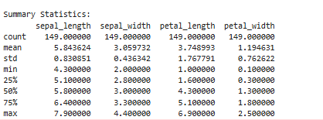

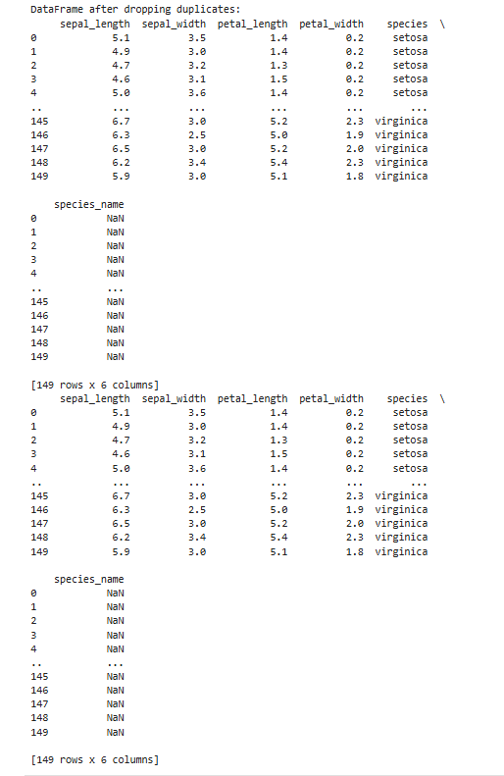

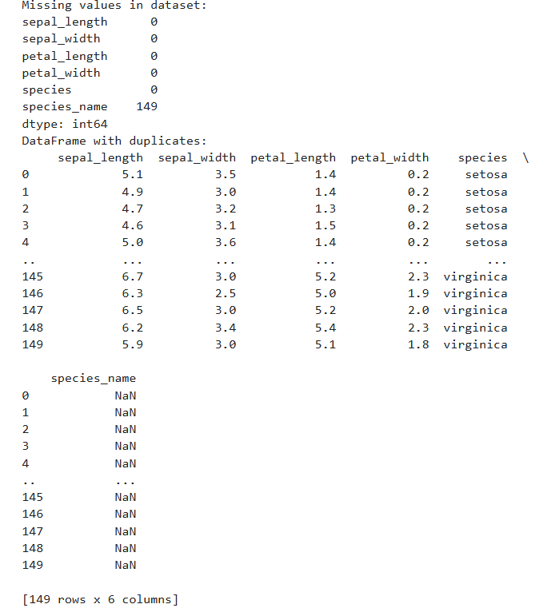
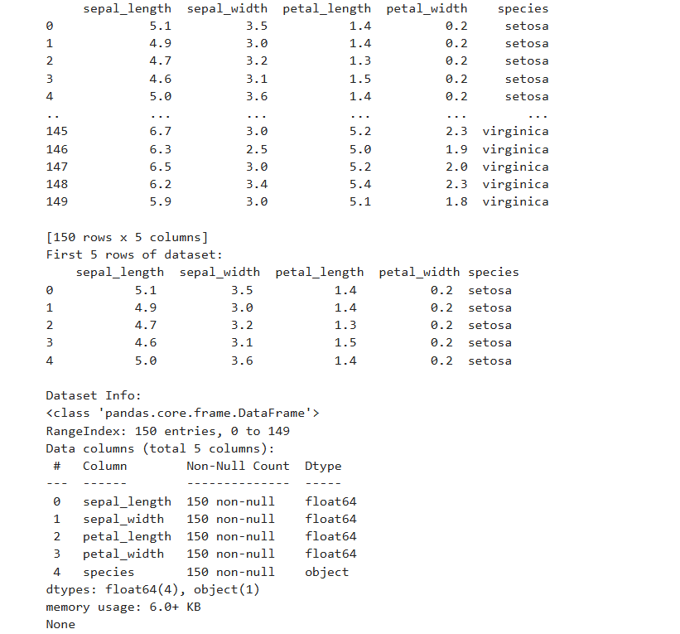
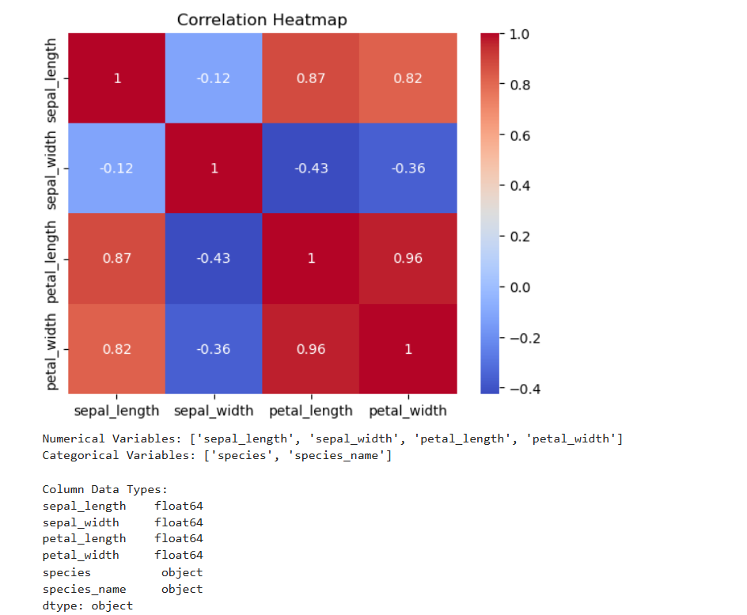
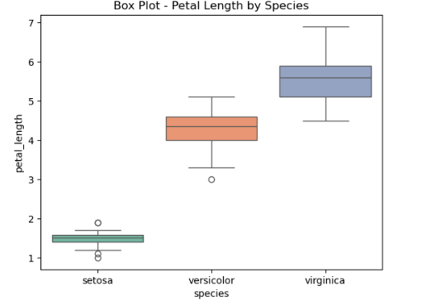
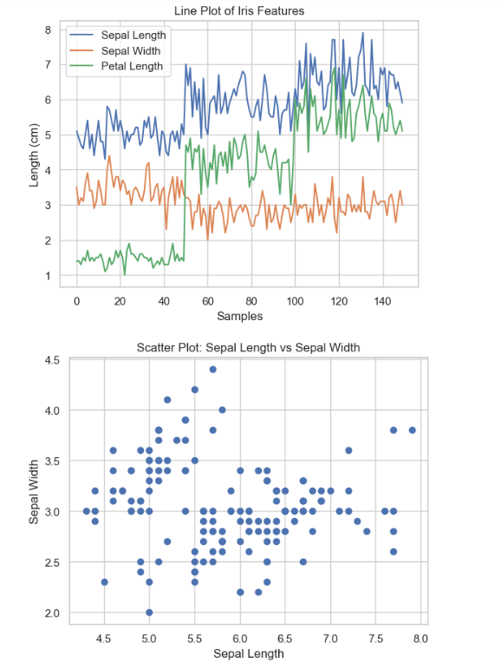
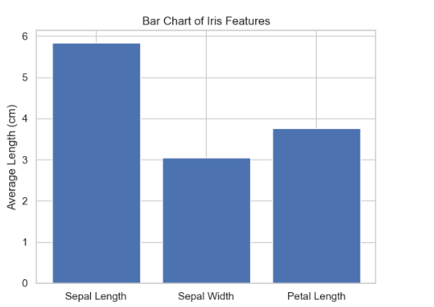
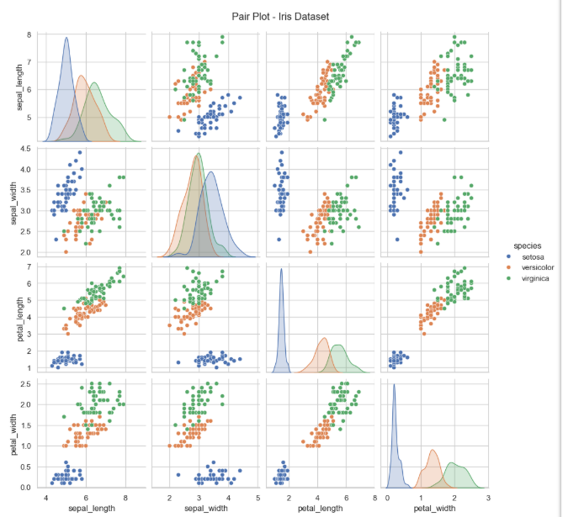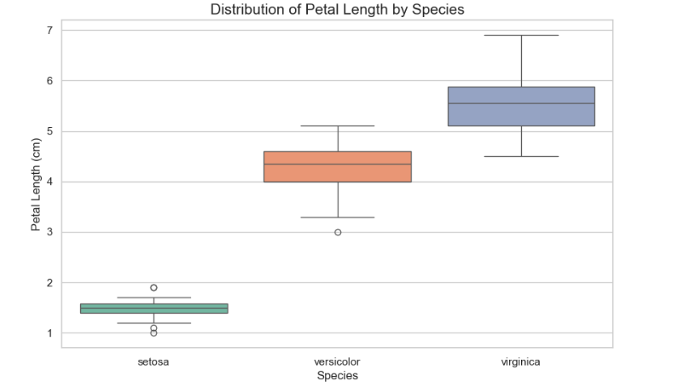
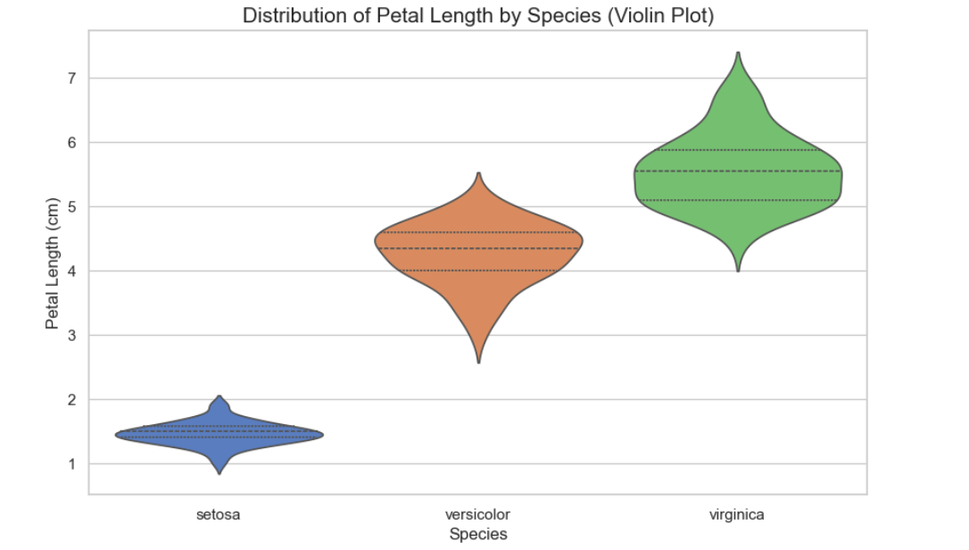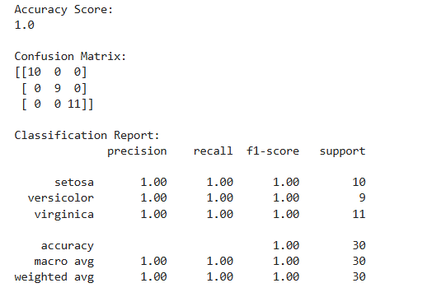

2.Use Regression Model
Example: Salary_Data.csv
import pandas as pd
import numpy as np
import matplotlib.pyplot as plt
import seaborn as sns
from sklearn.model_selection import train_test_split
from sklearn.linear_model import LinearRegression
from sklearn.metrics import mean_squared_error, r2_score

# 1. Data Loading
df = pd.read_csv('Salary_dataset.csv')

# Drop the index column from the CSV if present
if 'Unnamed: 0' in df.columns:
df.drop(columns=['Unnamed: 0'], inplace=True)

print("--- Step 1: Data Inspection ---")
print("First 5 rows:")
print(df.head())
print("\nData Info:")
df.info()
print("\nData Shape:", df.shape)

# 2. Data Cleaning
print("\n--- Step 2: Data Cleaning ---")
print("Missing values count:")
print(df.isnull().sum())

# Remove duplicates
initial_shape = df.shape
df = df.drop_duplicates()
print(f"Duplicates removed: {initial_shape[0] - df.shape[0]}")

# Ensure data types are correct
df['YearsExperience'] = df['YearsExperience'].astype(float)
df['Salary'] = df['Salary'].astype(float)

# 3. Exploratory Data Analysis (EDA)
print("\n--- Step 3: Exploratory Data Analysis ---")
print("Statistical Summary:")
print(df.describe())

print("\nCorrelation Matrix:")
corr_matrix = df.corr()
print(corr_matrix)

# 4. Data Visualization
# Distributions
plt.figure(figsize=(12, 5))
plt.subplot(1, 2, 1)
sns.histplot(df['Salary'], kde=True, color='blue')
plt.title('Salary Distribution')

plt.subplot(1, 2, 2)
sns.histplot(df['YearsExperience'], kde=True, color='green')
plt.title('Experience Distribution')
plt.savefig('distributions.png')

# Scatter Plot
plt.figure(figsize=(8, 6))
sns.scatterplot(x='YearsExperience', y='Salary', data=df)
plt.title('Years of Experience vs Salary')
plt.savefig('scatter_plot.png')

# Heatmap
plt.figure(figsize=(6, 4))
sns.heatmap(corr_matrix, annot=True, cmap='coolwarm')
plt.title('Correlation Heatmap')
plt.savefig('heatmap.png')

# Boxplots for Outliers
plt.figure(figsize=(10, 5))
plt.subplot(1, 2, 1)
sns.boxplot(y=df['Salary'])
plt.title('Salary Boxplot')

plt.subplot(1, 2, 2)
sns.boxplot(y=df['YearsExperience'])
plt.title('Experience Boxplot')
plt.savefig('boxplots.png')

# 5. Predictive Modeling (Regression)
# Split features and target
X = df[['YearsExperience']]
y = df['Salary']

# Split into Training and Testing sets
X_train, X_test, y_train, y_test = train_test_split(X, y, test_size=0.2, random_state=42)

# Initialize and train the model
model = LinearRegression()
model.fit(X_train, y_train)

# Make predictions
y_pred = model.predict(X_test)

# 6. Model Evaluation
mse = mean_squared_error(y_test, y_pred)
rmse = np.sqrt(mse)
r2 = r2_score(y_test, y_pred)

print("\n--- Step 6: Model Evaluation ---")
print(f"Mean Squared Error (MSE): {mse:.2f}")
print(f"Root Mean Squared Error (RMSE): {rmse:.2f}")
print(f"R-squared Score: {r2:.4f}")

# Final visualization of the model
plt.figure(figsize=(8, 6))
plt.scatter(X, y, color='blue', label='Actual Data')
plt.plot(X, model.predict(X), color='red', linewidth=2, label='Regression Line')
plt.xlabel('Years of Experience')
plt.ylabel('Salary')
plt.title('Linear Regression: Salary vs Experience')
plt.legend()
plt.savefig('regression_result.png')

Output
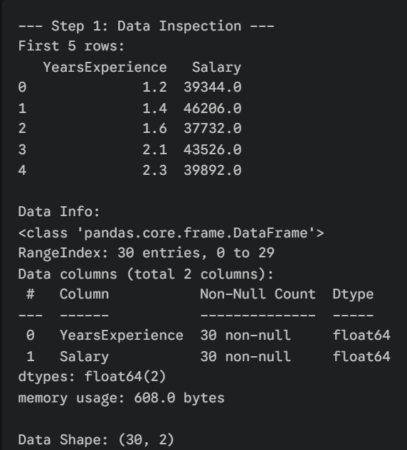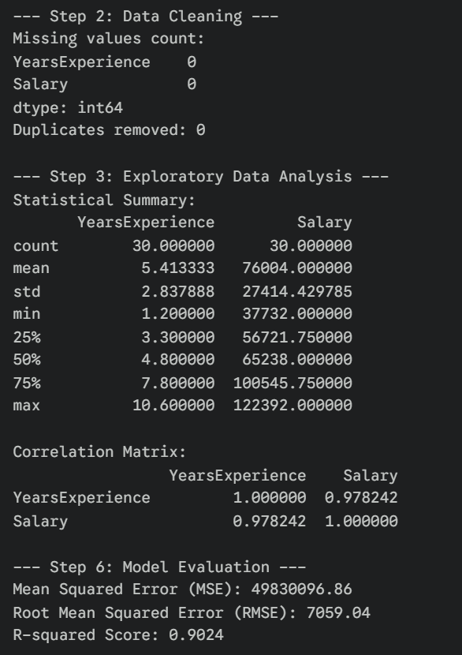
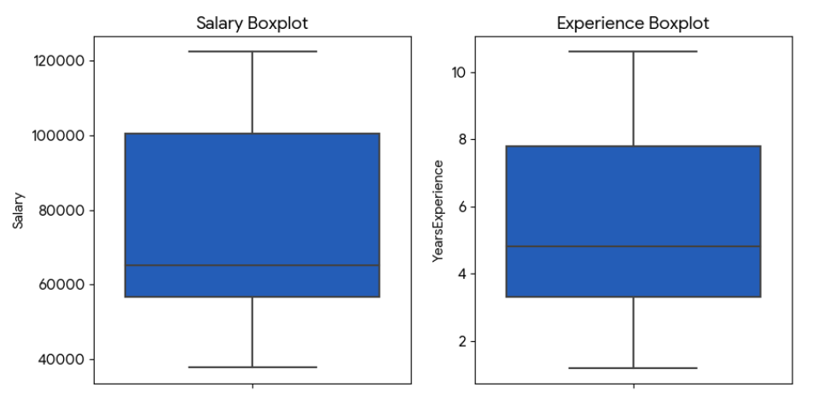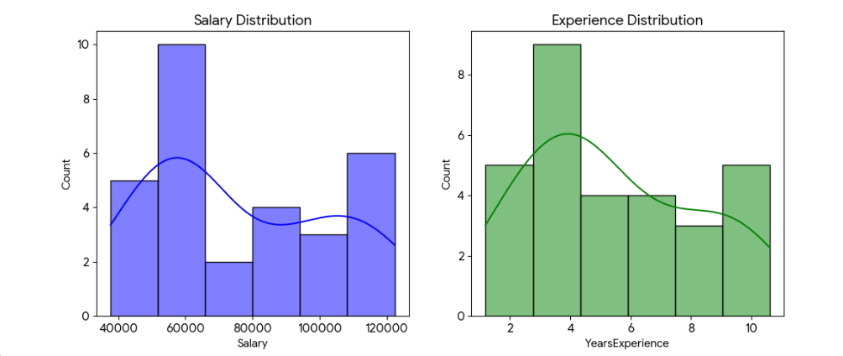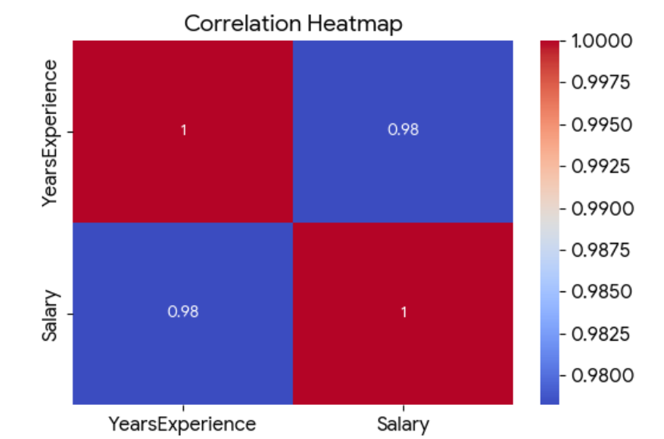
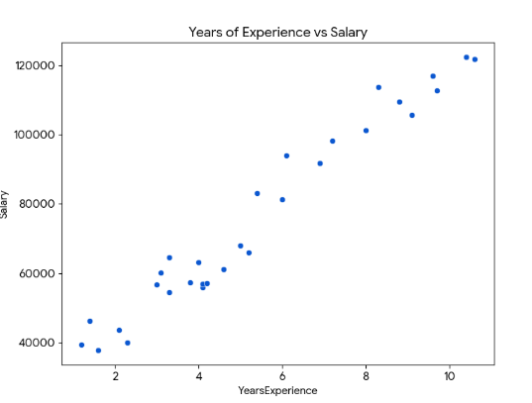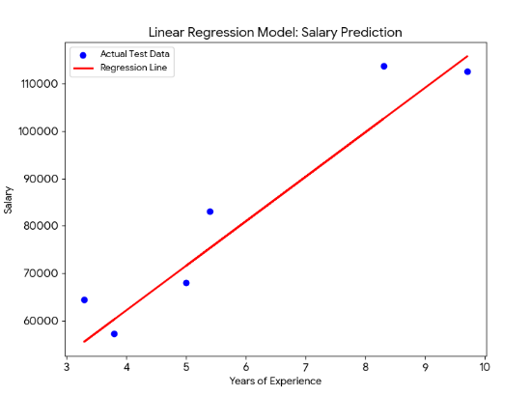

5.Conclusion
This project successfully classifies Iris species with high accuracy using standard ML pipelines, validating the dataset's utility for education. Insights confirm petal features' importance, paving the way for advanced techniques.
This project also successfully demonstrates a complete data science pipeline for analyzing and predicting employee compensation. The analysis revealed an exceptionally strong positive correlation between years of experience and salary, confirming that experience is a primary driver of pay scale in this dataset.

6.References
Jake VanderPlas, Python Data Science Handbook, O'Reilly, 2016.scikit-learn.org: Iris Dataset.Wikipedia: Iris flower data set.Kaggle: Iris Species Dataset.
Kaggle: Salary Dataset - Simple Linear Regression
GitHub Repository: DataScience_R_Codes - Salary_Data.csv

